Department of Computer Science and Engineering (Data Science)
CSDS-A | Batch A1 (CSE - Data Science, Section A)
AI Health Insurance Assistance Using LLM + RAG
(PolicyLens)
S.No. | Student name | Roll / hall ticket no.
1 | G.PRANATHI | 23K91A6764
2 | CH.AISHWARYA | 23K91A6747
3 | BHAVANSH MANE | 23K91A6728
4 | B.DEEKSHITH | 24K95A6701
Under the guidance of: [GUIDE NAME], [DESIGNATION]
SCOPE AND LIMITATIONS
This document states what PolicyLens covers and what it deliberately does not, the assumptions behind the design, and the honest limitations of the system and of the evidence for it.

1 Scope of the Project

1.1 In scope
- Health-insurance policy wordings in PDF form with a selectable text layer, including two-column layouts, tables and IRDAI exclusion codes.
- Parsing into numbered clauses with page numbers and highlight positions, and a viewer that shows the original page with the cited clause highlighted.
- A Policy Card of key terms (sum insured, waiting periods, co-payment, room-rent rule, sub-limits, exclusions, claim deadlines) with source and verification status for every value.
- Hybrid retrieval (BM25, dense embeddings, rank fusion, cross-encoder re-ranking) and cited answers with an NLI-based faithfulness score.
- Claim Copilot: calculated eligibility pre-checks, a verdict, a document checklist, claim steps and a cost estimate.
- Side-by-side comparison of two policies; risk highlights by severity; English, Hindi and Telugu questions, answers and card translation.
- A web application with accounts, a dashboard, a Model performance page, light and dark themes and a phone-friendly layout.
- An offline evaluation harness and a hand-built evaluation set drawn from four real policy wordings.

1.2 Out of scope
- Making or predicting the insurer's claim decision: PolicyLens explains the wording; the insurer decides.
- Scanned PDFs without a text layer (they are rejected with a clear message); optical character recognition is not included.
- Training or fine-tuning any model. Every model is pre-trained, and the evaluation set is used only to measure.
- Premium quotes, purchase, payment, claim submission to insurers or any integration with insurer systems.
- Medical advice, and policies other than health insurance.
- Uploads in languages other than English (questions and answers work in Hindi and Telugu, the wording must be English).
- Multi-user administration, roles beyond a single policyholder account, and production hardening such as HTTPS termination and rate limiting by IP.

1.3 Assumptions
- The uploaded wording is the policy the user holds and has a readable text layer in English.
- The Google Gemini API is reachable and the free-tier quota is not exhausted; when it is, the application falls back through a chain of models.
- One user works on one machine; the data folder stays on that machine.

2 System Boundary
The two diagrams below show the boundary of PolicyLens: what flows across it (context diagram) and who may do what inside it (use-case diagram).
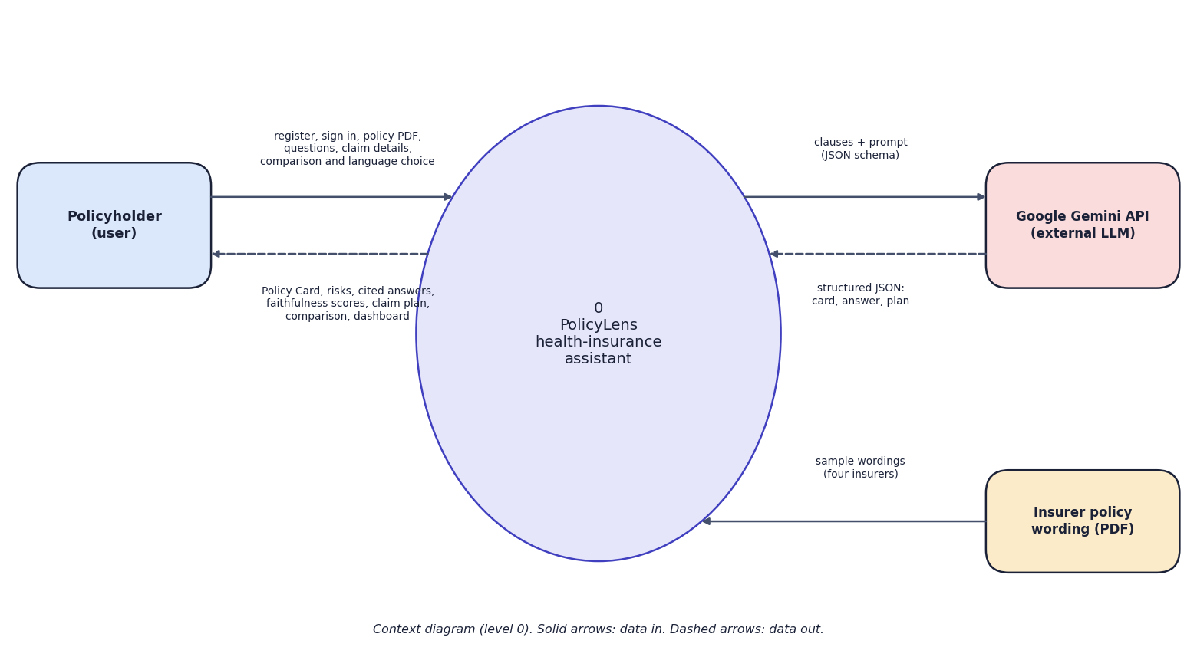
Fig. 1: Data-flow diagram, level 0 (context)
At the highest level PolicyLens is one process with three external entities. The policyholder sends credentials, policy PDFs, questions, claim details and comparison and language choices, and receives Policy Cards, risks, cited answers with faithfulness scores, claim plans and comparisons. The Gemini API receives clauses with a JSON schema and returns structured JSON. The insurer's policy wording is the input document, supplied either by the user or as one of four sample wordings.
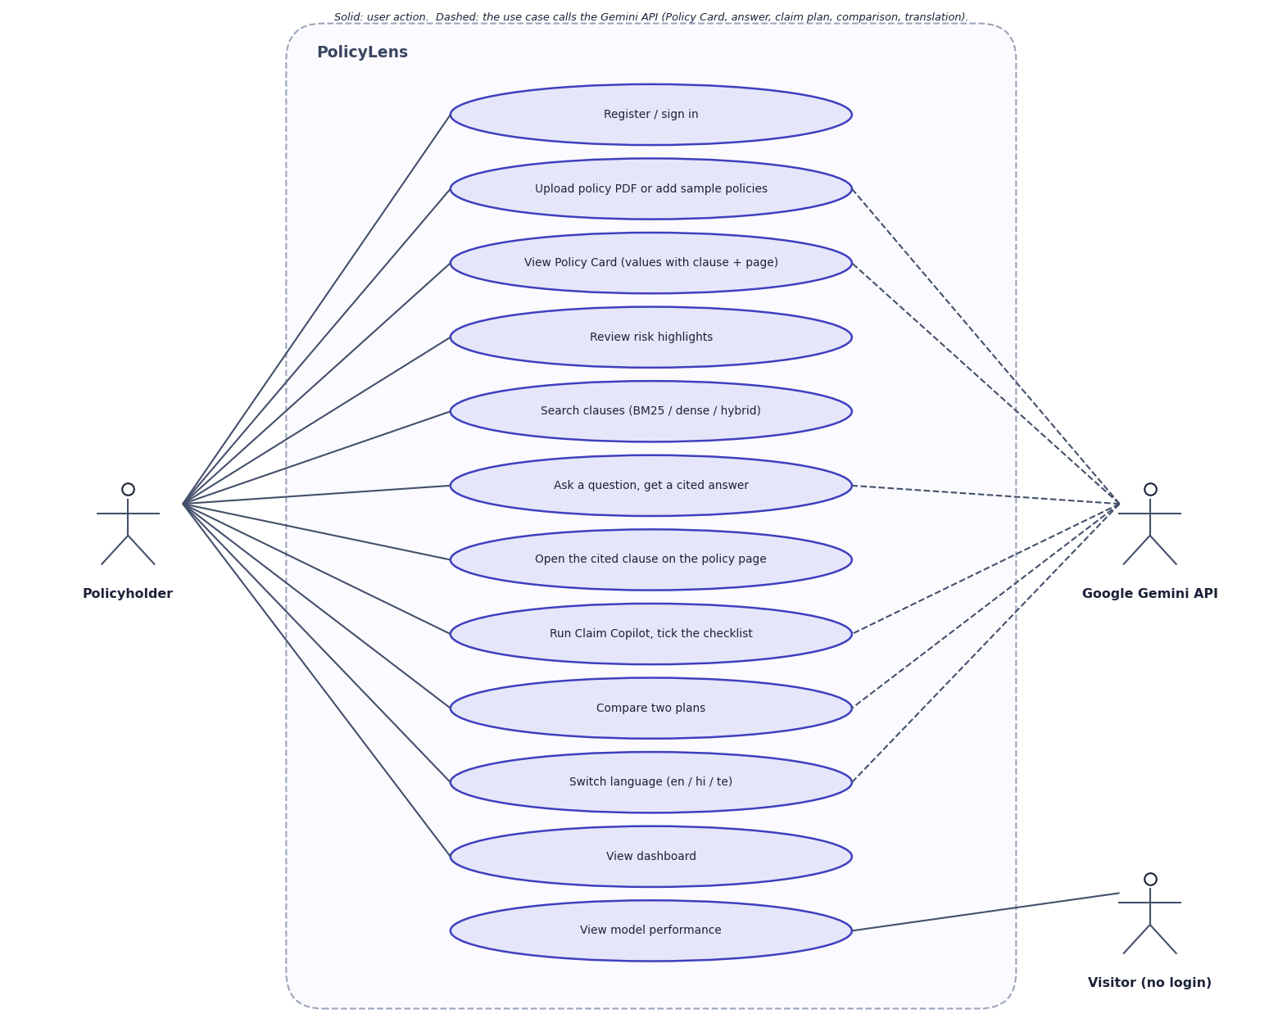
Fig. 2: Use-case diagram
The policyholder can register or sign in, upload a policy or add the samples, view the Policy Card, review risks, search clauses, ask questions, open a cited clause on its page, run Claim Copilot and tick its checklist, compare two plans, switch language and view the dashboard. A visitor who has not signed in can view the Model performance page. The Gemini API is an external actor used by the use cases that generate text: building the card, answering, claim planning, comparison and translation.

3 Limitations and Assumptions
- Small evaluation. 51 answerable questions over four policies and 14 claim scenarios. A result of 100% means no error was found on this set, not that errors cannot occur.
- Partly tuned on the evaluation set. The abstention thresholds and parser fixes were made after studying failures on the same set, so the final figures are optimistic; a fresh unseen set is future work.
- Smallest model in the chain. During the evaluation the free-tier quota of the two larger Gemini models was exhausted, so every result comes from gemini-3.5-flash-lite.
- Faithfulness is a heuristic. A small NLI model and a number check; three of 56 correct answers scored below 50, and one identical question scored 99.0 in one run and 37.9 in another.
- Translation quality. A Telugu Policy Card line contains Bengali and Gurmukhi script mixed into the Telugu text, and bracketed English terms are left untranslated.
- Plan variants. A wording that covers several plan variants (HDFC ERGO covers seven) can make a card value ambiguous; selecting the variant is not yet implemented.
- Text-layer PDFs only, English wordings only; no OCR.
- Single machine and single user. No load, concurrency or security testing was carried out, and no user study with real policyholders.
- No comparison on the base paper's metric. The base paper reports ROUGE for summarisation; PolicyLens does not summarise, so no numeric comparison is possible.

4 Advantages and Constraints
Table 1: Advantages and constraints of the project
Advantages | Constraints
Runs on one laptop with no GPU and no licence fee | Depends on an external model service and its free-tier quota
Documents stay on the user's machine; only clauses are sent to the model | Evaluated with the smallest model of the fallback chain
Every answer is cited and scored; the system can decline | Faithfulness score is a heuristic from a small NLI model
Rules (waiting periods, co-payment, estimate) are calculated, not generated | Text-layer, English wordings only; no OCR
Repeatable evaluation and public Model performance page | Small evaluation set; partly tuned on itself
English, Hindi and Telugu questions and answers | Translation quality limited (mixed-script line observed)

5 Limits of the Testing Done
- The 25 automated tests use a synthetic two-page policy and a stand-in for the language model; they do not test answer quality, which is measured separately.
- The evaluation set is small (51 answerable questions, 14 claim scenarios, 52 card values, four policies) and was used to tune the abstention thresholds and parser, so its results are optimistic.
- All results come from the smallest model in the fallback chain, gemini-3.5-flash-lite, because the larger models' free quota was exhausted; results with the larger models were not measured.
- No load, concurrency, security or penetration testing; one machine; one browser family (Chrome).
- No user study with real policyholders.

6 Limits of the Results
- Small set. 51 answerable questions over four policies. 100% here means no errors were found on this set, not that PolicyLens never errs. Every answer shows its sources and a faithfulness score for that reason.
- Tuned on the same set. The abstention thresholds and the parsing fixes were made after studying failures on this set, so the final figures are optimistic. The next check is a fresh question set on policy wordings PolicyLens has not seen.
- Model and quota. The Gemini model used depends on the free-tier quota at the time. The run records which model produced each result; all results here are for the smallest model in the chain.
- One machine, no user study. All timings are from one desktop; no load testing; no policyholder has rated the answers.
- No numeric comparison with the base paper is possible, as explained above.

